Intelligent Retail Customer Behavior Analytics and Recommendation Platform
Prepared by: P. Abhishek
ID No: 192324111
Subject: Software Engineering
Code: CSA 1013

1. Project Vision and Stakeholders
Vision: To design and implement an intelligent retail analytics platform that utilizes artificial intelligence and data analytics to understand customer behavior, predict future buying trends, and deliver personalized recommendations. The system aims to empower retailers with actionable insights for strategic decision-making, marketing optimization, and inventory management.
Objectives:
- Analyze customer purchasing and browsing patterns to uncover behavioral insights.
- Develop personalized recommendation algorithms to enhance user engagement.
- Predict future buying trends using machine learning models.
- Improve customer segmentation for targeted marketing campaigns.
- Optimize inventory management through predictive analytics.
- Generate interactive business intelligence dashboards for decision-makers.
- Increase customer retention and overall profitability.
Stakeholders:
- Retail Customers: Expect personalized, relevant product suggestions.
- Retail Business Owners: Seek improved sales and customer loyalty.
- Marketing Teams: Require accurate segmentation and campaign analytics.
- Inventory Managers: Need demand forecasting and stock optimization.
- Data Scientists/AI Engineers: Responsible for model development and tuning.
- Software Developers: Implement platform features and integrations.
- Executives/Decision Makers: Use dashboards for strategic planning.

2. Epics and User Stories
Epics:
- Customer Behavior Analytics
- Personalized Recommendation Engine
- Trend Prediction & Forecasting
- Customer Segmentation
- Marketing Campaign Support
- Inventory Optimization
- Business Intelligence Dashboards
Expanded User Stories:
- Customer Behavior Analytics: Analyze purchase history; visualize browsing behavior.
- Inventory Optimization: Demand forecasts; low-stock alerts.
- Personalized Recommendation Engine: Personalized recommendations; configure recommendation rules; track recommendation performance.

3. Acceptance Criteria
Demand Forecasting:
- Given historical transaction data is available.
- When the forecasting model runs.
- Then generate demand predictions for at least the next 30 days with >80% accuracy.
Low Stock Alerts:
- Given stock levels fall below a threshold.
- When shortage risk is detected.
- Then send an automated alert to the inventory manager.

4. Product Backlog Prioritization
High Priority (Sprint 1–2):
- Recommendation engine MVP
- Customer behavior analytics pipeline
- Basic BI dashboard
Medium Priority (Sprint 3–4):
- Trend prediction
- Customer segmentation
Lower Priority (Sprint 5+):
- Inventory optimization
- Advanced marketing support

5. Sprint Backlog (Sprint 1)
Selected User Stories:
- Personalized recommendations
- Recommendation rule configuration
- Recommendation performance dashboard
Actionable Tasks:
- Data ingestion
- Collaborative filtering algorithm
- Recommendation APIs
- Recommendation UI
- Admin interface
- Logging & analytics

6. Effort Estimation (Story Points)
Story Points:
- Personalized recommendations – 8
- Configure recommendation rules – 5
- Track recommendation performance – 3
Velocity:
- Team capacity: 16–20 story points per sprint.
- Sprint 1 fits within velocity.

7. Sprint Goal and Expected Deliverables
Sprint Goal: Deliver a functional MVP of the recommendation engine with personalized suggestions, configurable rules, and performance tracking.
Deliverables:
- Recommendation engine
- Recommendation UI
- Admin interface
- Analytics dashboard

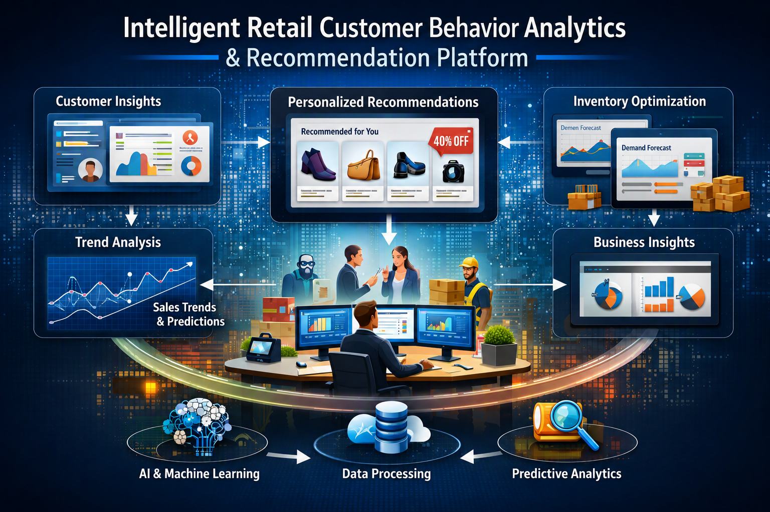

8. Additional Notes
Risks: Data quality, ML scalability, and integration challenges.
Dependencies: Transaction datasets, cloud infrastructure, stakeholder feedback.
Definition of Done:
- Code reviewed and tested
- Deployed to staging
- Acceptance criteria met
- Documentation updated

9. Executive Summary
Summary: This project combines AI, predictive analytics, and business intelligence to improve retail decision-making, customer engagement, and inventory optimization through Agile development.
The Intelligent Retail Customer Behavior Analytics and Recommendation Platform is an AI-powered retail analytics solution designed to help retailers understand customer behavior, improve decision-making, and enhance the overall shopping experience. Modern retail businesses generate large volumes of customer transaction and browsing data, but extracting meaningful insights from this data remains a significant challenge. This platform addresses that challenge by integrating machine learning, data analytics, and business intelligence into a single intelligent system.

